Unit 309: Produce and present advanced desserts and dough products using standardised recipes

Handout 4: Vegetable focaccia

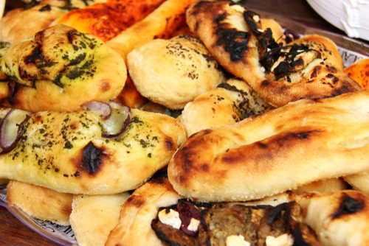

Ingredients

- 300g strong bread flour, plus extra for dusting
- 1 tsp table salt
- 30ml olive oil, plus 30ml for drizzling
- 7g fast-action dried yeast, or 23g fresh yeast
- 1 tbsp flat-leaf parsley, finely chopped
- 1 tbsp rosemary, finely chopped
- 1 tbsp dill, finely chopped
- 1 stick rhubarb, 20cm long, cut into 1cm-thick slices
- 1 red onion, thinly sliced
- 1/2 courgette, sliced lengthways into 3–5mm strips (roughly 4 strips)
- 1 tsp flaky sea salt
- 14 basil leaves
- 2 tbsp honey, for drizzling

Method

- Mix together the flour and table salt in a bowl.

- In a jug, combine 150ml tepid water with the olive oil and yeast (crumbling in the fresh yeast, if using) and mix together. Make a well in the flour and pour the liquid into the well. Mix to form a soft dough that leaves the sides of the bowl. Knead for 7–10 minutes, until smooth. This can be done by hand on a lightly floured surface or using a stand mixer fitted with a dough hook.

- Lightly grease the inside of a bowl with oil, place the dough in it and cover the bowl with lightly oiled clingfilm. Leave to rise in a warm place for about 1 hour, or until the dough has doubled in size.

- Once the dough has risen, add the chopped herbs to the bowl and knead them through the dough.

- Turn out the dough onto a floured work surface and roll it out into a large rectangle, approximately 18 x 30cm and 1cm thick. Push the rhubarb into the dough and top with the onion, courgette and two-thirds of the olive oil. Sprinkle with salt, place on a well-floured baking tray, cover loosely with oiled clingfilm and leave in a warm place to prove for 30 minutes.

- While the dough is proving, preheat the oven to 240°C/220°C fan/gas mark 8 with a heavy baking tray inside. After 20 minutes, drizzle the remaining olive oil on the tray and place it back in the oven.

- Carefully remove the hot, oiled tray from the oven and slide the proved dough onto it. Turn the oven down to 220°C/200°C fan/gas mark 7 and bake for 15 minutes. Remove from the oven, top with the basil leaves and drizzle with the honey and return to the oven for a further 10 minutes.

