Unit 309: Produce and present advanced desserts and dough products using standardised recipes

Handout 5: Raspberry soufflé

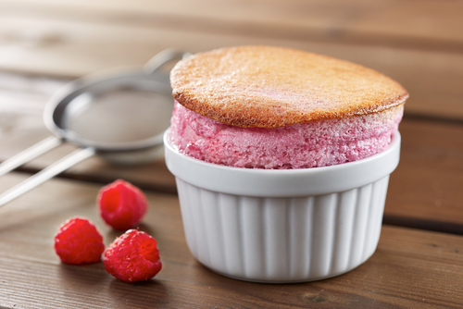

Ingredients

Raspberry soufflé base
1.5kg raspberry purée
750g caster sugar
150g cornflour

Raspberry soufflé mix
9 egg whites
90g caster sugar, plus extra for dusting

Garnish
Icing sugar for dusting

Method

- To make the raspberry base, dissolve the cornflour in a little cold water to form a smooth paste. Bring the purée and sugar to the boil then add the cornflour. Mix and simmer for a few minutes or until the purée doesn’t taste of cornflour. Pass through a sieve and cool.

- To make the meringue, whisk the egg whites till stiff, gradually adding the sugar during the whisking process. Mix 1/3 of the meringue into the raspberry base, and then fold in another 1/3 followed by the last 1/3 of meringue.

- Generously line the ramekins twice with butter then coat with a dusting of sugar. Fill the ramekins with the mix, flatten the top with a pallet knife and run your thumb around the edge to remove any excess.

- Bake in a preheated oven at 150ºC/Gas mark 2 for 14 minutes or until risen. Dust the top of the soufflé with icing sugar and serve immediately.

